**Fitting trait matching model to empirical networks:**

This is my first crude attempt to fit the trait matching model to empirical data:

I used data from Weinstein and Graham (2017) (Ecology Letters) to infer the parameters of the trait-matching model with thresholds:

$$α\left(z,z'\right)=\left\{\begin{aligned}e^{\left(-\frac{{\left(z-z^{'}\right)}^{2}}{ω^{2}}\right), \left|z-z^{'}\right|≤t*} \\ 0, Otherwise\end{aligned}\right.$$

Where, z and z’ are the trait values two competing individuals of different species.

$α\left(z,z'\right)$ is the strength of interaction, t* is the threshold to competition and ω is the ‘width of competition’.

Method:

1. I first measured the utility curves of each hummingbird species based on the interaction frequency data. Example of such curves is as follows:

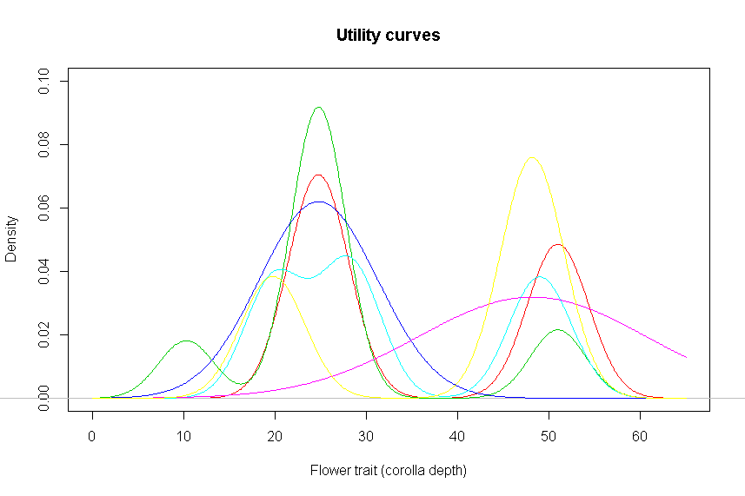

*This is a plot of utility curves of all the hummingbird species at a given location (data pooled for all the years) as a function of mean trait values of corolla depth of flowering species. These curves are smoothed by resampling the frequencies of interactions 500 times.*

1. Then I measured the % overlap between utility curves of each pair of hummingbird species. I will assume this overlap as a proxy for strength of interaction between the pairs of hummingbird species.
2. To see how well the trait-matching model fits these strengths of competition, I used bill length data for all the hummingbird species and used a following (non-continuous) linear model:

+ ε

Where, a= 1/(ω2) and x= -(z-z’)2

I used a crude method of minimizing the least squares for both the parameters (t* and omega)

Results for pooled data for 6 different transects is shown below. The estimates for t*, omega and pseudo r2 values are shown in legends.

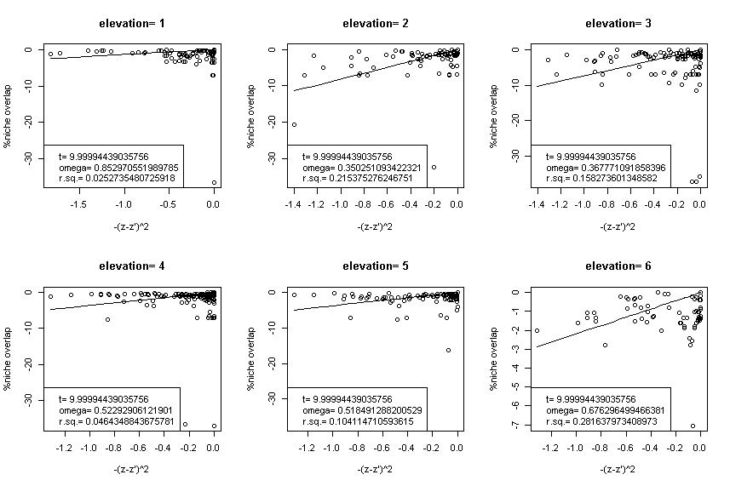

Notes: These are horrible fits. Also, t* estimates are always outside of the range of trait differences i.e. thresholds are too large to actually come into play.

[​Weinstein, B. G. and Graham, C. H. (2017), Persistent bill and corolla matching despite shifting temporal resources in tropical hummingbird-plant interactions. Ecol Lett, 20: 326–335. doi:10.1111/ele.12730](https://github.com/bw4sz/NetworkPredict/tree/master/InputData)